The Language of Community
We are learners in a group.
We make sense collectively.

We Us Our

The Language of Identity
As learners, we step into the role rather than passively learn.
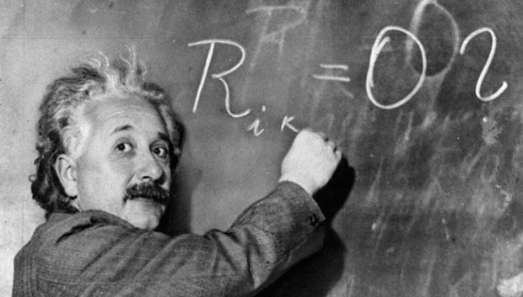
We are: Scientists, Authors, Mathematicians, Thinkers

The Language of Personal Agency
Learners take initiative and control their own actions.
How are you planning to…?
What are you wondering…?
What did you decide to do about that?

The Language of Naming and Noticing
Reinforce thinking by naming it.
That’s an interesting connection.
You have generated some new ideas.
That’s a new theory.

The Language of Knowing
Conditional vs. Absolute
Open the possibilities of ideas.
What is one perspective on that?
What might this be?
One way to solve the problem might be…?

The Language of Feedback
and Praise
Feeedback that values actions rather than ability.
You didn’t give up!
You put a lot of effort into that.
You found a lot of evidence for your thinking.

